**FORECASTING SALES OF STORE USING IBM WATSON STUDIO**

**Team - AI Project 5**

**Team Name - VIT-027**

**Team Members -**

1. Riddhirup Bera - 19BCE1169

2. Peddinti Vishnu Chakradhar Reddy - 18BCE7154

3. Subhro Mukherjee - 19BBS0142

4. Bharat Agarwal - 18BCE7052

5. Siddhant Jain - 19BBS0134

**Introduction To Project**

Forecasting of sales is an essential task for the management of a store. It is very important to be able to predict the sales of the store so as to be prepared with the inventory that they will need. So we are building a system that analyses the previous trends of sales which includes sales on various days and predicts future sales. This will be beneficial for both the store owners and customers as their will be sufficient supplies at all times.

**Problem Statement**

Build a project to forecast the sales of stores by using time series analysis using time series analysis algorithms such as RNN (Recurrent Neural Network) & LSTM (Long Term Short Memory) to analyze the past trends of sales of stores. Deploy flask-based web Application and integrate AI model to it.

The user should give the last ten days' sales values and get the prediction for the 11 th day which is showcased on the user interface.

**Solution**

1.First we collect the dataset.

2.Then we preprocess the data after importing the libraries and the dataset.

3.We then analyse the data by looking at its various parameters and then fill the missing values with the mean, median or mode as applicable or drop the column and rows.

4.We then do the feature scaling and visualize the data to analyse the data properly.

5.Then we split the data into train and test set and create a dataset using sliding window.

6.Then we create the model the model starting with importing the model building libraries.

7.We then initialize the model by adding the LSTM and output layers.

8.We then train and evaluate the model.

9.After that we save the model.

10.Then we integrate it with flask to create the user interface.

11.Then we deploy the model using IBM Cloud.

**Literature Survey**

[1] Y. Bengio, I. Goodfellow, and A. Courville. Deep Learning. Book in preparation for MIT Press, 2015.

[2] K. Cho, B. van Merrienboer, C. Gulcehre, F. Bougares, H. Schwenk, and Y. Bengio. Learning phrase representations using RNN encoder-decoder for statistical machine translation. In EMNLP, pages 1724– 1734, 2014.

[3] A. Graves. Generating sequences with recurrent neural networks. arXiv preprint arXiv:1308.0850, 2013

**Experimental Investigations**

1.Shape of inputs plays a major role in the correctness of the model.

2.IBM Cloud helps to deploy machine learning models and test the correctness of our model.

3.Integrating Flask with the machine learning model involves a lot of data preprocessing to make the predictions correctly.

**Software Specifications**

We used Anaconda and Jupyter Notebook to preprocess the data and create the model. Spyder was used for integrating Flask with the project and IBM Cloud was used to deploy the model.

**Flow Chart**

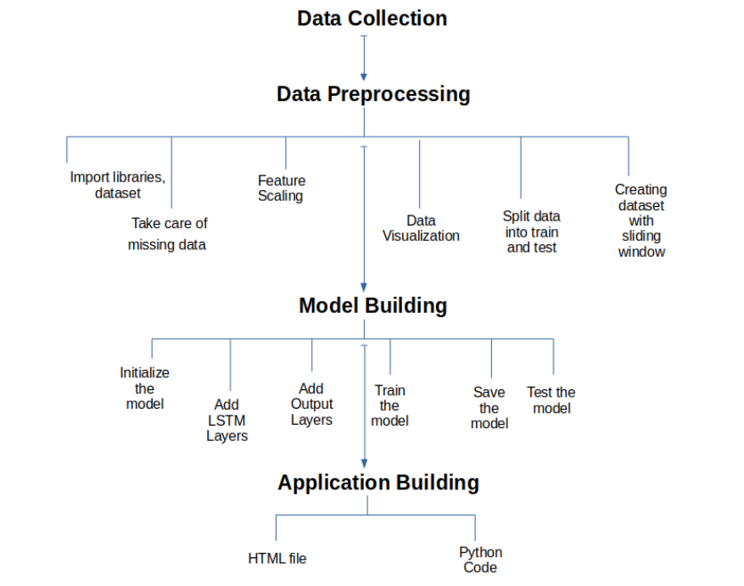

**Conclusion**

Thus we are able to predict the sales of the 11th day after giving the inputs of the last 10 days.

**Future Scope**

This project can be used by large companies to predict their sales which would create a big impact on national economy and government policies. This can also be used to predict the import and export statistics of the country and help in supporting the economy of the country.

**Bibliography**

1.Sundermeyer, Martin / Schlüter, Ralf / Ney, Hermann (2012): "LSTM neural networks for language modeling", In INTERSPEECH-2012, 194-197.

[2] I. Sutskever, O. Vinyals, and Q. V. Le. Sequence to sequence learning with neural networks. In NIPS, pages 3104–3112, 2014.

[3] S. Hochreiter and J. Schmidhuber. Long short-term memory. Neural Computation, 9(8):1735–1780, 1997.